IMPLMENTATION OF STATISTICAL PROCESS CONTROL IN METEOROLOGICAL DEPARTMENT BY USING MATLAB

1st P.Pavithran
Assistant Professor/Department of Mechanical Engineering
Ramco Institute Of technology
Rajapalayam,India
pavithran@ritrjpm.ac.in
4th P.Krithika
IV year/ Electrical and Electronics Engineering
Ramco Institite Of Technology
Rajapalayam, India
953618105011@ritrjpm.ac.in
2nd M.Nalliraj Madhavan
IV year Mechanical Engineering
Ramco Institite Of Technology
Rajapalayam, India
953618114043@ritrjpm.ac.in
5th M.I.Rohini
IV year/ Electrical and Electronics Engineering
Ramco Institite Of Technology
Rajapalayam, India
953618105020@ritrjpm.ac.in
3rd S.Keerthana
IV year/ Electrical and Electronics Engineering
Ramco Institite Of Technology
Rajapalayam, India
953618105010@ritrjpm.ac.in
7th Dr.S.Rajakarunakaran
Head /Department of Mechanical Engineering
Ramco Institute Of technology
Rajapalayam,India
rajakarunakaran@ritrjpm.ac.in
6th S.Sridharan
IV year Mechanical Engineering
Ramco Institite Of Technology
Rajapalayam, India
953618114070@ritrjpm.ac.in

Abstract—This paper focused on implement and monitoring the statistical process control (SPC) in Indian meteorological department center with the broad objective of understanding the weather forecasting variability and collecting the statistics required for the agriculture, water resource management and warn against the nature calamities. Chennai Meteorological department is one among the six meteorological departmental centers in India. Control chart is data monitoring process used for controlling the variations and finding the root cause problem. In this case, data gather from the IMDC and incorporate in control charts for identifying how tolerance limits of weather measurement value is exceeding in the region of Tamil Nadu . MATLAB is a matrix and mathematical programming software which is used here for plotting the control charts and also draw the graph of weather forecasting for understand the rainfall data.
Keywords - Control charts, MATLAB, Meteorological, statistical Process Control, Total Quality Management, Weather forecasting.

Introduction
Generally in the meteorological department the weather reports are forecasted not predicted. A forecast is an estimate of a future event achieved by systematically combining and casting forward, in a predetermined way, data about the past. The concept used in forecasting is the ‘throw ahead’ technique. Requires a pattern in data. Whereas prediction is based on intuition the concept used in prediction is the ‘saying ahead’ technique. Can be used to predict form random data. In forecasting the error analysis is possible. In this statistical process control the error and data samples can be regulated various errors and sample can be analyzed and model is frame. Statistical Process Control (SPC) applies statistical methods to monitor and control a process to operate at full potential. Statistical process control is a collection of tools that when used together can result in process stability and variance reduction. The data retrieved from IMDC are fed through the control charts model made using MATLAB.
The preparatory phases of SPC involve several steps, using a number of different tools. Seven quality tools are available to help organizations to better understand and improve their processes. The essential tools for the discovery process are: Check Sheet, Cause-and-Effect Sheet, Flow Charting, Pareto Chart, Scatter Diagram, Histogram or probability plot and Control Charts. The Control charts may be classified: (i) control charts for variables and (ii) control charts for attribute. The control charts based on variable data that can be measured on a continuous scale i.e. weight, volume, temperature etc. are known as control charts for variables. The control charts based on discrete data i.e. counted as ‘present’ or ‘not’ are called control charts for attributes. When constructing attribute control charts, a subgroup is the group of units that are inspected to obtain the number of defects or the number of defective items.

Control charts structure:
A control chart is composed of three items: (1) center line (CL), (2) control limits (CLs), and (3) monitoring statistic by sample dots. Based on the inspection or measurement of quality characteristics from the obtained sample, control charts are classified into two types: control charts for variables and for attributes. In other words, if the quality characteristics are measurable and continuous value, such as weight, length and so on, then control charts for variables are used. The most common control charts for variables have the following two kinds: (1) Mean and range chart (X − R chart) and (2) Mean and standard deviation chart (X − S chart).
Theory of x̅ chart:

In X̅ chart, means of small samples (3-5) are taken at regular intervals, plotted on a chart, and compared against two limits. The limits are known as upper control limit
(UCL) and lower control limit (LCL). These limits are defined as under:

LCL = x̅ - A₂R and UCL = X + A₂R
Where,
x̅ is the target mean and factor A2 depends on sample size. The process is assumed to be out of control when the sample average falls beyond these limits.

Theory of Range (R) charts:
In these charts, the sample ranges are plotted in order to control the variability of a variable. The centerline of the R chart is known as average range. The range of a sample is simply the difference between the largest and smallest observation. If R1, R2... R_{k}, be the range of k samples, then the average range (R bar) is given by:-
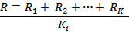
The upper and lower control limits of R chart are:
Upper control limit: Lower control limit:
UCL_{R =} D₄ * R̅ LCL_{R} = D₃ * R̅
Where,
Factors, D3 and D4 depend only on sample size (n)

Litererature review
Gurusaheb Singh Missan and Dr. I. P.Keswani (2016) [1] proposed the energy in the gasoline (perhaps 70%) is converted into heat, and it is the job of the cooling system to take care of that heat. Pareto analysis is a statistical technique in decision making that is used for the selection of a limited number of tasks that produce significant overall effect. Using Pareto technique the causes of overheating in 25 engines were studied in which cooling system is considered it is found that coolant, radiator and fan were the critical causes of overheating.
Mamta Parmar et al (2016) [2] was developed the concept of control with regard to variation, and came up with SPC charts which provide a simple way to determine if the process is in control or not. A typical control chart has control limits set at values such that if the process is in control, nearly all points will lie within the upper control limit (UCL) and the lower control limit (LCL). By using the quality tools and statistical techniques quality can be achieved. SPC with the help of control charts can give the significance improvement to the quality from the all above quality tools .
Jafri mohd rohani and Chank kok teng (2001) [3] had designed to improve the quality of plastic injection moulded lenses used in telecommunication devices. Quality goals can be included in the business plan and as a degree of a product or service excellence provided to customer. Data collected showed that the average defect has improved to 7.4 % from 13.49 % initially.
B.P. Mahesh and M.S. Prabhuswamy (2003) [4] has described as a strategic management technique that plays a vital role in the company’s operations management. It is customary to take the six sigma prime spread in the distribution of the product quality characteristic as a measure of process capability. The cause and effect analysis is one of the simplest and cheapest measurement tools for improving the production system quality efficiency which gives tangible benefits in the shortest possible time for any organization.
Prof. J.A. Doshi et al (2012) [5] has designed the root causes and sub-causes which produce the problem or defect are represented in that respective heads. The Ishikawa diagram method becomes more powerful tool when it’s used with brainstorming and cross functional team, which helps to identify causes of problem with different point of view. The tools and techniques like Failure Mode Effect Analysis or Pareto Analysis, etc may be used to priorities.
Long-Hui Chena et al (2011) [6] had proposed the statistical process control (SPC) identifies whether the production processes have changed or not, or the occurrence of assignable variations, by the analysis of quality characteristic data in order to improve the production processes before the irregular products created. Since true probability π t has been changed to apparent probability π e when inspection error exists, two models have been presented to modify classic multinomial control charts. When type I error is fixed, the out-of-control ARL results show that Model I (adjust true probability π t ) works better than Model II (adjust statistical values).
Dr. D. R. Prajapati (2012) [7] has proposed Statistical process control (SPC) is the application of statistical methods to the monitoring and control of a process to ensure that it operates at its full potential to produce conforming product.It uses statistical tools to observe the performance of the production process in order to predict significant deviations that may later result in rejected product. SPC analysis may easily help in improving the efficiency of the manufacturing process thus decreasing the number of defective products, thus saving a lot of re-work cost and valuable time.
Pranay S. Parmar et al (2014) [8] analyse the Success in the global market depends on quality. Companies don’t design poor quality; it is usually the result of a variation in some stage of production. The concept of variation states that no two products will be perfectly identical even if extreme care is taken to make them identical. The SPC knowledge is important to the implementation and proper guidance is required. SPC is most effective when it is integrated into an overall, companywide quality improvement program.
Rami Hikmat Fouad and Adnan Mukattash (1993) [9] explains that Jordan Steel (JS) is a Public Limited Company (P.L.C.) established in 1993 with a production capacity of 300,000 MT tons per year. Quality control procedure at JS works along the value chain starting from the supplier’s evaluation and selection, receiving raw material (Billets) all the way to after sales services, there is a necessity in JS to introduce ongoing education and training programs of management and line staff on interrelation between SPC tools and its implementation steps.

PROBLEM IDENTIFICATION:
The Deviation in the weather forecasting and representation of the variance was in the form of static data our aim is to represent these information as a dynamic data which is collected from different places can be plotted using these SPC and deviation can be easily identified either it may high rainfall region or low rainfall region can be identified using our MATLAB model. Data representation error can be rectified.

METHODOLOGY:
One of the best technical tools for improving product and service quality is statistical process control (SPC). There are seven basic techniques. Since the first four techniques are not really statistical, the word statistical is somewhat of a misnomer. Furthermore, this technical tool not only controls the process but has the capability to improve it as well. (SPC) is a technique used within the TQM framework for reducing variation in processes which we deal with every day. In this tool for identifying problems and make improvements.
A control chart is a graph that displays data taken over time and the variations of this data. Uses of control charts are: To check whether the process is controlled statistically or not, to determine process variability, to establish the process capability of the production process, to determine the effects of process changes. And the two basic types of control chats are: Control charts for variables and Control charts for attributes.
A.Control charts for variables:
The quality characteristics which can be measured and expressed in specific units of measurements are called variables. Control charts based upon measurements of quality characteristics are called as control charts for variables. Types of variables control charts are: X bar or average charts, R or range charts and s or standard deviation chart. The X bar chart is used to monitor the centering of the process to control its accuracy.
The R chart monitors the dispersion or precision of the process.
The s chart shows the variation of the process.

Control charts for attributes:
An attribute refers to those quality characteristics that conform to specifications or do not conform to specifications. Control charts for attributes monitor the number of defects or fraction defect rate present in the sample. Types of attributes control charts are: p chart, np chart, c chart and u chart.
p chart: The chart for fraction rejected as non-conforming to specifications.
np chart: The control chart for number of non-conforming items.
c chart: The control chart for number of non-conformities.
u chart: The control chart for number of non-conformities per unit

Flow chart:

START

Research survey

Problem statement

Paper objectives

Collecting the data

Import Data in matlab

Analyze the data

Conclusion

END

TABLE 1 IMD Weather Forecasting Report
SI.NO | Alerts | Locations in Tamil nadu | Rainfall/storm (mm/cm) | Actions
1 | Red alerts | Chennai, thootukudi, Ramanthapuram and nagapattinam | 25 | Take action
2 | Orange alerts | Niliris, thenkasi, Dindigul, Theni | 6 to 20 | Be preapared
3 | Yellow alert | Virudhunagar, Madurai, thiruvanamalai, villupuram, chengalpat | 5 | Be alert

TABLE 2 – Cause effects in rainfall actions
SI.NO | No of days | Terms | Probability of occurrence | Category
1 | Dec 21 | Unlikely | < 25 | Isolated (ISOL)
2 | Dec 22 | Likely | 25 - 50 | Scattered (SCT/ A few places)
3 | Dec 23 | Very likely | 50 - 75 | Fairly widespread (FWS/Many places)
4 | Dec 24 | Most likely | > 75 | Widespread (many places)

TABLE 3 Winter Monsoon Rainfall 2022
SI.NO | Places in Tamilnadu | Actual in mm | Normal in mm | PDN
1 | Ariyalur | 77.7 | 19.1 | 307
2 | Chengalpet | 31.2 | 14.5 | 201
3 | Chennai | 10 | 35 | 22
4 | Coimbatore | 22.6 | 24.7 | 43.4
5 | cuddalore | 38.3 | 45.7 | 55
6 | Erode | 48.8 | 45.3 | 57.2
7 | Nammakal | 35.8 | 32 | 78.0
8 | Coimbatore | 55 | 11.6 | 89
9 | Madurai | 89.2 | 12.5 | 29
10 | Sivagangai | 49 | 34.5 | 57.8
11 | Viruddhunagar | 55.3 | 24.7 | 67.9
12 | Thenkasi | 23.5 | 44 | 25.7
13 | Ramnad | 1.1 | 43 | 37.9
14 | Tuticorin | 44.3 | 26.3 | 66
15 | Kanyakumari | 38.5 | 22.9 | 69
16 | Villupuram | 45.9 | 32.6 | 98
17 | Karur | 86.7 | 23 | 201
18 | Dindigul | 66.2 | 19.6 | 232
19 | Pudukottai | 74.3 | 16.7 | 372
20 | Tirupur | 34.9 | 17.9 | 300.7
21 | Dharaapuram | 80.1 | 26.8 | 145.5
22 | Nilgiris | 56 | 23 | 43
23 | Kallakurichi | 46 | 34 | 34
24 | Kanchipuram | 27 | 50 | 33
25 | Ranipet | 67 | 42 | 46
26 | Salem | 87.4 | 7.8 | 77
27 | Theni | 77 | 5.6 | 48
28 | Thanjavur | 34 | 4.1 | 44
29 | Tirichy | 28 | 48.7 | 89
30 | Thirupattur | 55 | 5.6 | 66
31 | Thiruvallur | 88 | 11 | 98
32 | Thiruvanamaali | 111 | 12 | 231
33 | Vellore | 121.5 | 24.5 | 167
34 | Villuppuram | 105 | 44.3 | 189
35 | Krishnagiri | 121 | 23 | 79
36 | Nagapattinam | 128.6 | 52.1 | 80

Figure1 – Matlab – X chart and R chart from Table 3
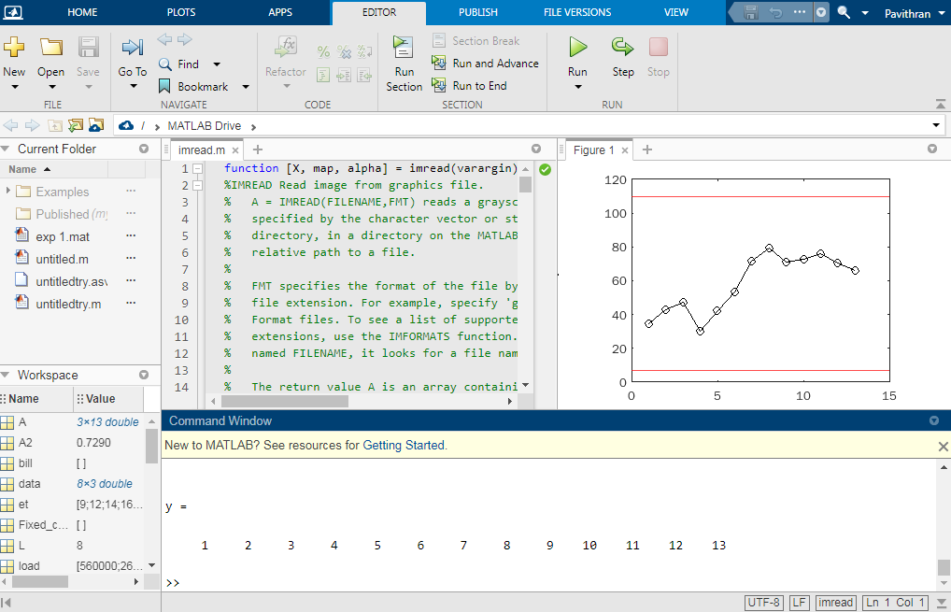
Actual – Maximum 128.6
Minimum 1.1
Normal – Maximum 52.1
- Minimum 4.1
PDN – maximum 372
- Minimum 29
*PDN – percentage departure from nominal
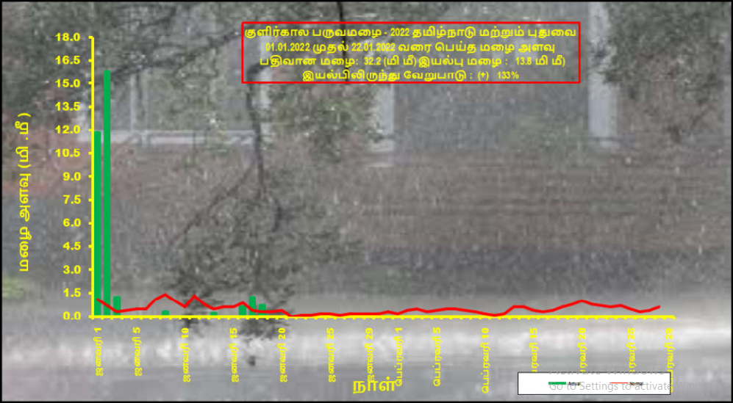
Figure 2 rainfall rate in tamilnadu and puducherry from 2022, January 1 to 24
From the readings, upper control limit = 372
Lower Control limits = 29
Control limits = 78
CONCLUSION
From the above study it can be concluded that basic requirement of the weather forecasting variability is studied and then the statistical process control is implemented and monitored. The control chart used here is to study how the process changes over time and by comparing the data to draw conclusion about weather measurement value exceeding the region of tamil nadu. On taking into the consideration of different sampling measurement and sampling interval the graph was plotted in the MATLAB Software

FUTURE SCOPE
The key with control charts is to recognize when anything is happening outside the norm. Want to develop an action plan for how to respond when the latest measure lands outside the acceptable limits. We can also add the different region monitoring system this will help in identifying problems in various places. Based on the data we collected we can predict the future problems on certain interval.
About the authors:
 Mr.P.Pavithran, working as an Assistant Professor in Mechanical Engineering in Ramco instutute of Technology from spetember 2020. His area of interest is materials, machining, industrial engineering and additive mnaufacturing
Ms.S.Keerthana, pursuing her final year in Electrial and Electronics Engineering, Ramco Institiute of Technology, Her area of interest in project is Smart applications in EEE, management concept and power systems.
Ms.P.Kithika, pursuing her final year in Electrial and Electronics Engineering, Ramco Institiute of Technology, Her area of interest in project is Smart applications in EEE, management concept and power systems.
 Ms.M.I.Rohini, pursuing her final year in Electrial and Electronics Engineering, Ramco Institiute of Technology, Her area of interest in project is Smart applications in EEE, management concept and power systems.
Mr.S.Sridharan, pursuing his final year in Mechanical Engineering, Ramco Institiute of Technology, His area of interest in project is Smart applications in Mechanical,, management concept and automation  Mr.M.Nalliraj Madhavan, pursuing his final year in Mechanical Engineering, Ramco Institiute of Technology, His area of interest in project is Smart applications in Mechanical,, management concept and automation
Dr.S.Rajakarunakaran, Vice principal, HOD/Mechanical department in Ramco Institute of Technology. His area of interest Materials, machining and industrial engineering. He has Guideship under anna university. Also contribute as DC member to many aspiring phd scholars.
RESULT
From Table 3, it clearly shows the rainfall happened in the year is highly than previous year. This time it causes huge disasters. By applying the concept in the paper is helps the people in future to shows the storm rate in all over the districts in tamilnadu for avoiding collateral damages

M = 58.50
R bar = 70.64
S = 17.09

Figure 3 Control charts in x chart and R chart
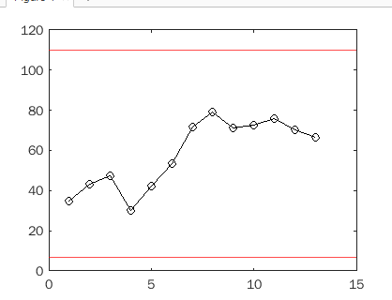

Acknowledgment
We thank Dr.S.Rajakarunakaran and Mr.P.Pavithran for their guidance who supported the work with resourceful learnings. We thank to Chennai international meteorological center for taking the reading from their website and work on it..

References

- Gurusaheb singh missan and Dr.I.P. Kswani , “Analysis of Causes of Engine overheating the due to cooling system failure using pareto priniple”, International journlas of Engineering trends and Technology volume 36, Number 5, June 2016
- Mamta Parmar, Er.Harpreet singh oberoi, Er.Gaurav Kalia and Harpreet kaur, “Diagnostic tools to revive sick manufacturing unit s using SPC (Statistical process control) ”, International journal for research and development in technology, volume 5, Issue 6, June 2016
- Jafri mohd rohani and chank kok teng, “Improving quality with basic statistical process control tools: a case study”, jurnal teknologi, 35 a, 2001: 21-34, February 2007

- B.P.Mahesh and M.S. Prabhusamy, “Process variability reduction through statistical process control for quality improvement ”, International journal for quality resaerch, short scientific paper (1.03), Volum4, No3, 2010
- Prof J.A. Doshi, J.D.Kamdar, Prof S.Y. Jani and prof.S.J. Chaudhray, “Root cause analysis using Ishikawa diagram or reducing radiator rejection”, International journlas for engineering research and applications, Vol 2, Issue 6, December 2012.
- Long hui chen, Fengming M.chang and Yueh Li chen, “The application of multinomial control charts for inspecting error”, International journal for industrial engineeing, 18(5), 244-253, 2011
- Dr.D.R.Prajapathi, “Implementation of SPC Techniques in automotive industry: a case study”, imternational journlas for emerging technology and advanced engineering, Volume 2 , Issue 3, March 2012
- Pranay s parmar and vivek A.Deshpande, “Implementation of statistical process control (SPC)”, Journal for emerging technologies and innovative research Volume 1, Issue 6, November 2014
- https://www.hindustantimes.com/india-news/tamil-nadu-rain-4-dead-orange-alert-issued-cyclonic-circulation-persists-101636421011365.html
- Rami hikmat fouad and Adnan mukattash, “Statistical process control tools: A parctical guide for jordanian industrial organisations”, jordan journal of mechanical and industrail engineering, , volume 4, No 6, pp 693-700, december 2010
- http://www.imdchennai.gov.in/dailyweekly.pdf
- https://www.newindianexpress.com/cities/chennai/2021/dec/30/heavy-and-continuous-rains-lash-chennaiimd-issues-warning-for-dec31jan1-2401344.html

